1. cmdlets are just another word for the commands we use within PowerShell.
2. Help related commands

Get-Help Get-Process

Get-Help Get-Process -Full

Get-Help Get-Process -Detailed

Clear

Get-Command

Get-Command -Verb Get

Get-Command -Noun “*Time*”

Get-Module -ListAvailable

Get-Command -Module PSReadLine

1. Run “Update-Help” to update the help files
2. Everything in Powershell is an OBJECT

* 1. Sample Commands

Get-Process | Select-Object ProcessName | Sort-Object ProcessName

Get-Process | Where-Object ProcessName -EQ "System"

Get-Process | where {$_.ProcessName -EQ "System"}

$var = Get-Process | where {$_.ProcessName -EQ "System"}

$var

Even variable is also an Object in PowerShell

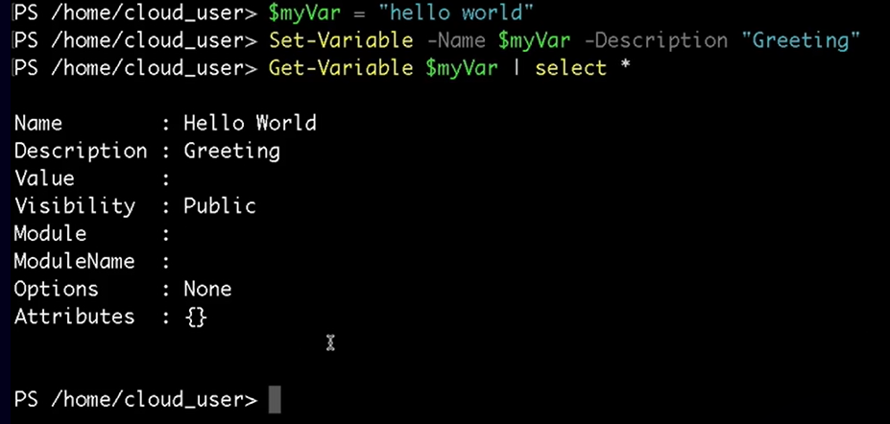

1. MODULES = Modules are basically just sets of cmdlets that have been packaged up together.

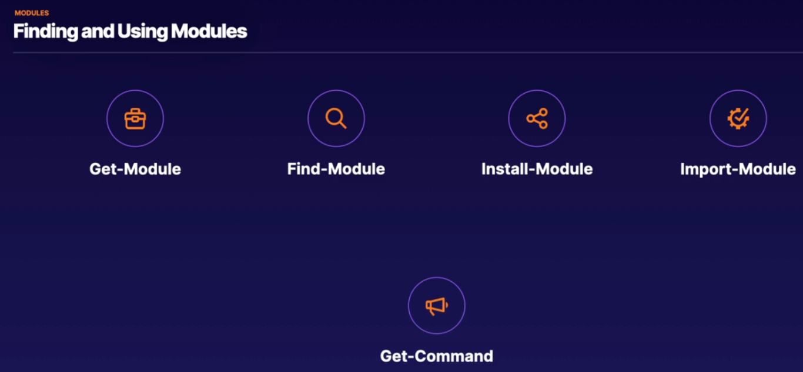

1. Get-Module vs Get-Module -ListAvailable

the difference between these two lists is simply which ones I have already imported, which as you can see is only PS read line and which ones are available on the system. So you can see in the second list there aren't many available.

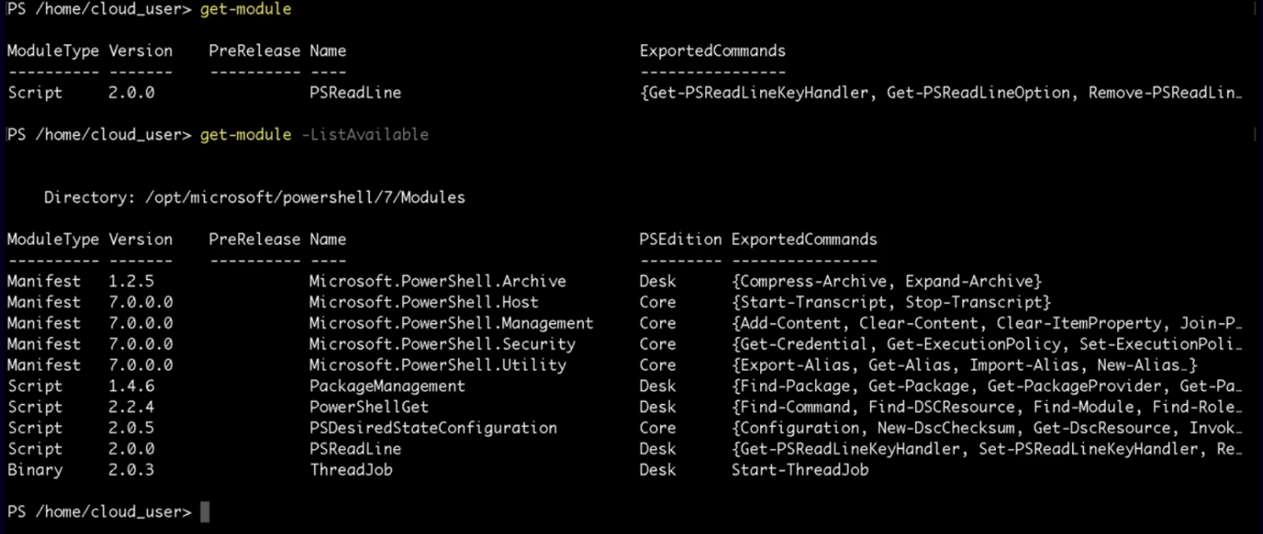

1. Sometimes when you install software, the PowerShell module for that software will come installed with it but many times we need to go out to the internet and find it through PowerShell gallery and there is a built in way to find modules on PowerShell gallery.
2. it's going to run out to the internet and look for that and after a quick moment, it returns information that this is indeed available out on PS gallery.



1. INSTALL-MODULE

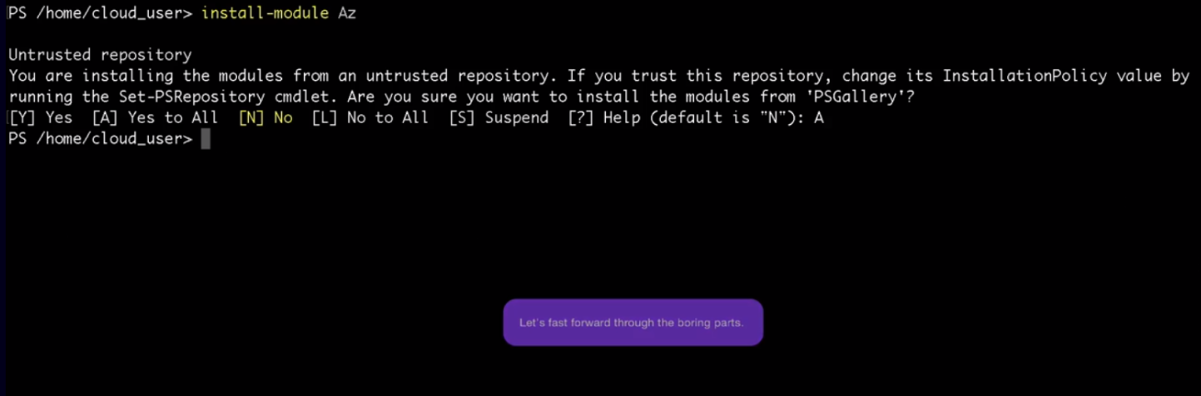

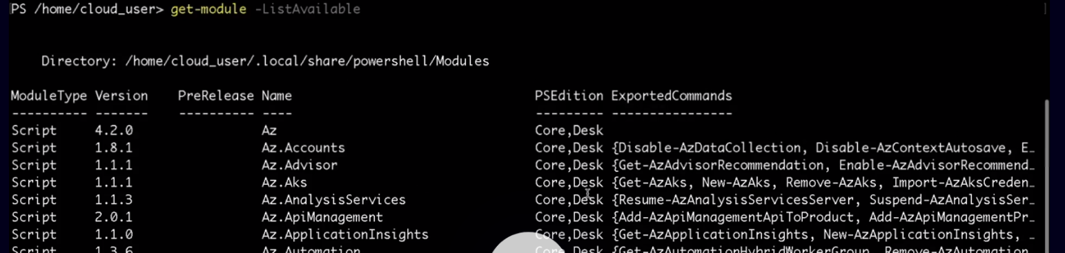

1. But if you try Get-Module, you can notice that these new AZURE cmdlets are not yet imported

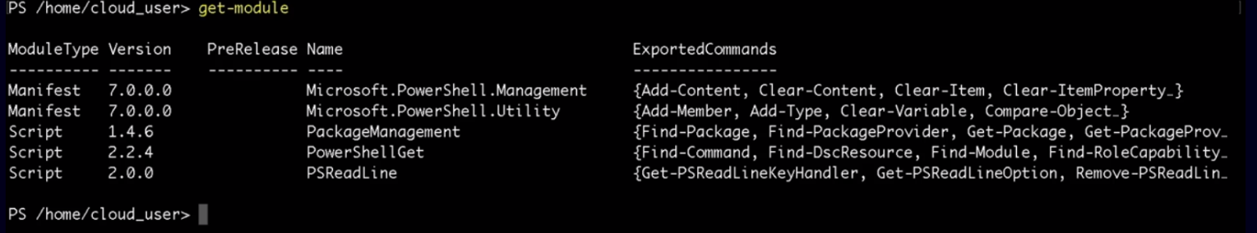

1. IMPORT-MODULE

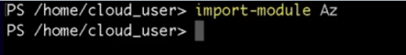

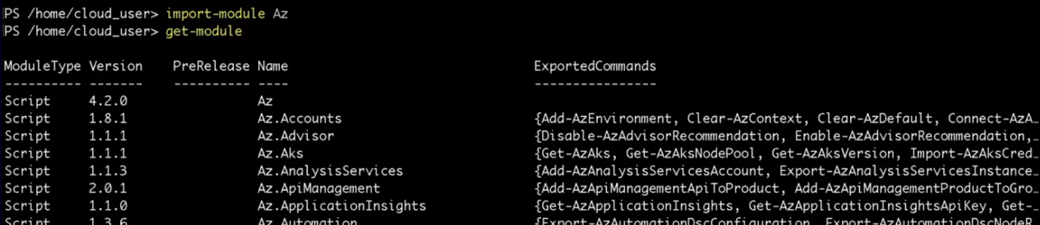

1. you know how to install the modules that you're looking for but how do you go about knowing which commands are available within those modules? Well, that ties back to our friend, get-command

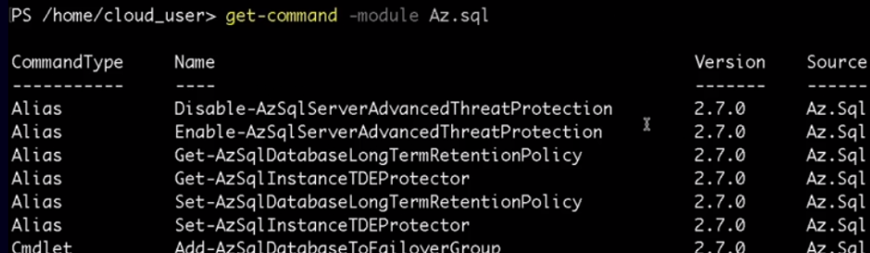

1. Unlimited power with Powershell comes from just chaining together. One of the strengths of PowerShell is that you can utilize various modules and the commands within them to chain together, very intelligent and powerful commands.
2. NEXT COURSE TO LOOK INO
3. **Cross-Platform PowerShell in Azure**